Sisällys

Pycharm key-shortcuts 6

Links: 6

Apps: 6

Section 3 6

Strings in Python 6

Variables (value binding) 6

Bytecode with Python - how to compile python to exe 6

Numeric Data Types (int, float, decimal, complex - Python3) 7

Numeric operators 7

Operator Precedence 7

Slicing (needed at least one column :) 7

Using Step in a Slice 7

Slicing backwards 8

Python String Types (f format in use Python >= 3.6) 8

Section 4 8

Using debugger 8

Conditional Operators 8

Simplify Chained Comparison 8

Boolean expressions (True or False with capital) 8

Operator Precedence Table 8

String methods 8

For loops 9

Python Build-in Functions 9

Continue 9

Break 9

While 9

Binary Search 9

Augmented Assignment 9

Pep 8 9

Section 5 – List and Tuples (sequence types) 9

Iterables have either: 9

Mutable objects 10

Methods and Function 10

Enumerate 11

Sorting 11

Built-in-Functions 11

Sorting 11

Case sensitive sorting 12

Creating Lists (about 20 ways to do it) 12

Replacing a slice 12

Deleting items from a list 13

Safely removing items from a list 13

Testing 13

Removing items from list – backwards (Lesson 108) 13

The Reversed Function https://docs.python.org/3/library/functions.html 14

Algorithms Performance 14

Pep8 – style guide 14

Trailing commas 14

Processing Nested Lists 14

No spam with menu-list (2 different approaches) 14

Print revisited 15

The join method (lists) 15

The split method 16

Tuples are immutable 16

Unpacking Tuples 16

Nesting Further 17

Constants 17

Section 6 - Functions – introduction 17

Palindromes 17

String functions 17

Range exercise 16 - sum(range(start, n, 2)) 17

Handling invalid arguments (positional-or-keyword) 18

Docstrings (using reStructuredText) 18

Fibonacci numbers 19

Documenting 19

Function annotations and type hints 19

Function annotations with default value 19

Running program on terminal (msdos / powershell) 19

Playing Fizz Buzz -game 20

Defining different argument types 20

Section 7 20

What is a dictionary 20

Zen of Python 21

Using in with dictionary 21

Checking quantities – tuple or dict 22

setdefault -method 22

Exercise 20 – char counter 23

APIs and mobile phone demo 23

- https://docs.python.org/3/library/getpass.html 23

The dict documentation 23

Python Branches 23

dict objects 24

Shallow copy Lesson 205 copies only reference 24

Hash functions 24

Tools – Python Console (console woindow) 24

Hash tables 24

hashlib 24

Introduction to sets 25

set membership 26

Better performance 26

Unique data in sets 27

Set documentation 27

The `pop` method 27

Set union 27

Symmetric Difference (you could use list) 28

Subsets and supersets 28

isdisjoint(other) 29

Summary 29

Section 8 Input and Output I/O 30

Pickle 30

Shelve 30

Section 9 Modules and Functions 30

Modules and import 30

The Standard Python Library 30

Webrowser Module 31

Time and Datetime in Python 31

Installing pytz module (FAQ) 31

Installing pytz 31

Using Timezones 32

Tkinter 32

Import System 32

Lesson 288 recursive or iterative 32

Factorial and Fibonacci 32

OS module 33

Nonlocal keyword, FREE and LEGB 33

Section 10 – Object Oriented Programming 33

Capsulation in Classes check from material 33

Static Methods: 34

Namespaces: 34

DocString and Raw Literals 35

Artist Class and import Albums (with circular reference) 35

Compare Files and Algorithm Flowcharts 35

If using Python 2 in song.py 35

Challenge – remove circular references (aim to top diagram) 38

Getters and Setters 38

Inheritance (Python allows multiple inheritance but be aware that you should master it) 38

Python no method overloading 39

Python overriding 39

tab Regex + (\{\d\.) + $1_ Replace All 39

Inheritance Challenge Lesson 314 40

Polymorphism (Java in statically typed – Python dynamically typed) 41

Inheritance isn’t the only way to implement polymorphism Lesson316 41

Composition Lesson 317 & 319 HTML document demo 41

Relationship described with 41

Aggregation (weak form of composition) Lesson 320 41

Section 11 – Using Databases with Python 42

Introduction to SQLite 42

Querying data with SQLite 42

Autoincrement in SQLite 43

More Complex Joins 44

Wildcards and Views 44

Views (for customer security plus to easy job) 45

Housekeeping and Challenge 46

SQL Challenge 47

SQL in Python 49

SQL Injection Attacks (parameter substitution with placeholders, sanitizing the input) 49

Placeholders and Parameter Substitution 49

Exceptions 49

Hints (CTRL + Q) 49

Adding Database code to Accounts Class 49

Displaying Time in Different Timezones 49

SQLite3 strftime Function 50

Challenge and Problems Storing Time zones 50

- https://www.sqlite.org/lang_corefunc.html 50

- https://www.sqlite.org/lang_aggfunc.html 50

Jukebox (Music Browser) 50

Star args 50

Jukebox final 51

Questions 53

# Pycharm key-shortcuts

* ALT + SHIFT + arrow up
* CTRL + ALT + L (reformat code)
* CTRL + Q python docs

# Links:

* <https://www.javatpoint.com/python-tutorial>
* <https://www.timbuchalka.com/>

C:\Users\lauri\PycharmProjects\PythonMasterClass\

* <https://www.tutorialspoint.com/sqlite/sqlite_distinct_keyword.htm>

# Apps:

* Diffmerge
* C:\Users\lauri\Koodivertailu

# Section 3

## Strings in Python

## Variables (value binding)

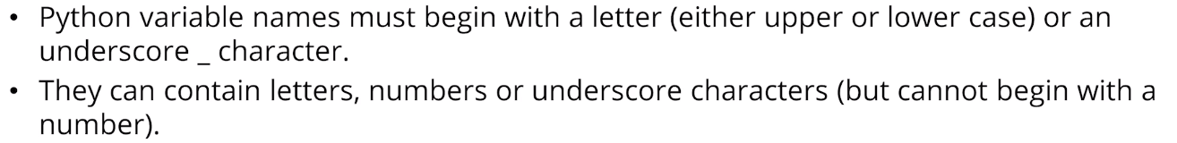

## Bytecode with Python - how to compile python to exe

* <https://www.youtube.com/watch?v=NJB6RT0tsLI> (simple)
* <https://www.youtube.com/watch?v=UZX5kH72Yx4>
* pip list
* pip install pyinstaller
* pyinstaller --oneFile --w main.py
* NSIS Wiki, download NSIS

## Numeric Data Types (int, float, decimal, complex - Python3)

OBS! Int



Float 52 digits precision

## Numeric operators

a = 12  
b = 3  
  
print(a + b) *# 15*print(a - b) *# 9*print(a * b) *# 36*print(a / b) *# 4.0*print(a // b) *# 4 integer division, rounded down towards minus infinity*print( a % b) *# modulo 0: the remaider after integer division*

## Operator Precedence

## Slicing (needed at least one column :)

print(parrot[10:])

### Using Step in a Slice

number = **"9,223;372:036 854,775;807"***# print(number[1::4])*separators = number[1::4]  
print(separators)  
values = **""**.join(char **if** char **not in** separators **else " " for** char **in** number).split()  
print([int(val) **for** val **in** values])

### Slicing backwards

letters = **"abcdefghijklmnopqrstuvwxyz"**backwards = letters[::-1]

## Python String Types (f format in use Python >= 3.6)

*print(f”{value} is greater”) – print(“{} is greater”.format(value))*

# Section 4

## Using debugger

## Conditional Operators

## Simplify Chained Comparison

*if age >= 16 and age <= 65:***if** 16 <= age <= 65:

## Boolean expressions (True or False with capital)

### Operator Precedence Table

* <https://docs.python.org/3/reference/expressions.html#operator-precedence>

## String methods

* <https://docs.python.org/3/library/stdtypes.html#string-methods>

## For loops

## Python Build-in Functions

* <https://docs.python.org/3/library/functions.html>

## Continue

* <https://stackoverflow.com/questions/8420705/example-use-of-continue-statement-in-python>

## Break

## While

## Binary Search

low + (high – low)/2

## Augmented Assignment

* guessed += 1
* <https://docs.python.org/3/reference/expressions.html>

## Pep 8

* <https://www.python.org/dev/peps/pep-0008/>
* <https://www.python.org/dev/peps/pep-0013/>

# Section 5 – List and Tuples (sequence types)

* <https://docs.python.org/3/library/stdtypes.html#sequence-types-list-tuple-range>

## Iterables have either:

__iter__ method

__getitem__ method

* <https://docs.python.org/3/library/functions.html#id>

## Mutable objects

* <https://docs.python.org/3/library/stdtypes.html#mutable-sequence-types>

### Methods and Function

* <https://docs.python.org/3/library/stdtypes.html#string-methods>

#### dot notation

s.append(x)

## Enumerate

**for** index, character **in** enumerate(**"abcdefgh"**):  
 print(index, character)

## Sorting

even = [2,4,6,8]  
odd = [1,3,5,7,9]  
  
even.extend(odd)  
print(even)  
another_even = even  
print(another_even)  
  
even.sort(reverse=**True**)  
print(even)  
print(another_even)

## Built-in-Functions

* <https://docs.python.org/3/library/functions.html>

## Sorting

## Case sensitive sorting

* word.casefold()

## Creating Lists (about 20 ways to do it)

* <https://stackoverflow.com/questions/2612802/list-changes-unexpectedly-after-assignment-why-is-this-and-how-can-i-prevent-it/43220129#43220129>

## Replacing a slice

* <https://docs.python.org/3/library/stdtypes.html#mutable-sequence-types>

## Deleting items from a list

This doesn’t work in Python as in Java or C, you can’t handle loop control variable

data = [4,5,104,105,110,120,130,130,150,160,170,183,185,187,188,191,350,360]min_valid = 100  
max_valid = 200  
  
**for** index, value **in** enumerate(data):  
 **if** (value < min_valid) **or** (value > max_valid):  
 **del** data[index]  
  
print(data)

## Safely removing items from a list

## Testing

* <https://en.wikipedia.org/wiki/Edge_case>
* <https://en.wikipedia.org/wiki/Corner_case>

## Removing items from list – backwards (Lesson 108)

data = [104,101,4,105,308,103,5,107,100,306,106,102,108]  
  
min_valid = 100  
max_valid = 200  
  
**for** index **in** range(len(data) -1, -1, -1): *# backward, step -1* **if** data[index] < min_valid **or** data[index] > max_valid:  
 print(index,data)  
 **del** data[index]  
  
print(**'-'**\* 30)  
print(data)

## The Reversed Function <https://docs.python.org/3/library/functions.html>

* <https://docs.python.org/3/library/functions.html>
* <https://docs.python.org/3/library/functions.html#reversed>

## Algorithms Performance

## Pep8 – style guide

* <https://www.python.org/dev/peps/pep-0008/>

### Trailing commas

my_list = [

1, 2, 3,

4, 5, 6,

]

## Processing Nested Lists

### No spam with menu-list (2 different approaches)

*# First workin example***for** meal **in** menu:  
 **for** index **in** range(len(meal) -1, -1, -1):  
 **if** meal[index] == **"spam"**:  
 **del** meal[index]  
  
 print(meal)  
  
print(**'-'**\*30)  
  
*# Second workin example***for** meal **in** menu:  
 **for** item **in** meal:  
 **if** item != **"spam"**:  
 print(item,end=**" "**)  
 print()

## Print revisited

## The join method (lists)

* https://docs.python.org/3/tutorial/datastructures.html?highlight=lists
* flowers = [  
   **"Daffodil"**,  
   **"Evening Primose"**,  
   **"Hydrangea"**,  
   **"Iris"**,  
   **"Lavender"**,  
   **"Sunflower"**,  
   **"Tiger Lily"**,  
  ]  
    
  *# for flower in flowers:  
  # print(flower)*separator = **", "**output = separator.join(flowers)  
  print(output)  
    
  print(**","**.join(flowers))

## The split method

generated_list = [**'9'**,**' '**,  
 **'2'**,**'2'**,**'3'**,**' '**,  
 **'3'**,**'7'**,**'2'**,**' '**,  
 **'0'**,**'3'**,**'6'**,**' '**,  
 **'8'**,**'5'**,**'4'**,**' '**,  
 **'7'**,**'7'**,**'5'**,**' '**,  
 **'8'**,**'0'**,**'7'**]  
values = **""**.join(generated_list)  
print(values)  
  
values_list = values.split()  
print(values_list)

*# replace the values in place***for** index **in** range(len(values_list)):  
 values_list[index] = int(values_list[index])  
print(values_list)  
  
  
*# create a new list*integer_values = []  
**for** value **in** values_list:  
 integer_values.append(int(value))  
print(integer_values)

## Tuples are immutable

* <https://docs.python.org/3/library/stdtypes.html#common-sequence-operations>
* <https://docs.python.org/3/library/functions.html>

## Unpacking Tuples

albums = [(**"Welcome to my Nightmare"**, **"Alice Cooper"**, 1975),  
 (**"Bad Company"**, **"Bad Company"**, 1974),  
 (**"Nightflight"**, **"Budgie"**, 1981),  
 (**"More Mayhem"**, **"Emilda May"**, 2011),  
 (**"Ride the Lightning"**, **"Metallica"**, 1984),  
 ]  
  
print(len(albums))  
  
**for** album **in** albums:  
 print(**"Album: {}, Artist: {}, Year: {}"** .format(album[0], album[1], album[2]))  
  
print(**'-'** * 30)  
  
**for** name, artist, year **in** albums:  
 print(**"Album: {}, Artist: {}, Year: {}"** .format(name, artist, year))  
  
print(**'-'** * 30)  
  
**for** album **in** albums:  
 print(**f"Album: {album[0]}, Artist: {album[1]}, Year: {album[2]}"**)

## Nesting Further

## Constants

SONGS_LIST = 3

**from** nested_data **import** albums

# Section 6 - Functions – introduction

## Palindromes

Do gees see god? - true

desnes not far, rafton sensed – true

### String functions

* <https://docs.python.org/3/library/stdtypes.html#string-methods>

### Range exercise 16 - sum(range(start, n, 2))

**def** sum_eo_Tim(n, t):  
 *"""* **if** t == **"e"**:  
 start = 2  
 **elif** t == **'o'**:  
 start = 1  
 **else**:  
 **return** -1  
  
 **return** sum(range(start, n, 2))  
  
  
x = sum_eo_Tim(10, **'e'**)  
print(x)

## Handling invalid arguments (positional-or-keyword)

* <https://docs.python.org/3/library/exceptions.html>
* <https://docs.python.org/3/glossary.html#term-parameter>

## Docstrings (using reStructuredText)

* <https://www.python.org/dev/peps/pep-0257/>

help(get_integer)  
  
**'''  
print(input.__doc__)  
print("*" * 80)  
print(get_integer.__doc__)  
print("*" * 80)  
'''**

## Fibonacci numbers

0,1,1,2,3,5,8,13,21,34,55

* <https://en.wikipedia.org/wiki/Fibonacci_number>

### Documenting

* <https://devguide.python.org/documenting/>

## Function annotations and type hints

**def** is_palindrome(string: str) -> bool:

* <https://docs.python.org/3/library/typing.html>
* <https://www.python.org/dev/peps/pep-3107/>

## Function annotations with default value

* <https://www.python.org/dev/peps/pep-0008/> (CTRL + F on the page)

When combining an argument annotation with a default value, however, do use spaces around the = sign

## Running program on terminal (msdos / powershell)

* file open in terminal (mouse right click) and get the path
* python -V

installing colorama with pip to PyCharm: (from the path where you saved the python wheel file)

C:\Users\lauri\PycharmProjects\PythonMasterClass\Section6>pip install C:\Users\lauri\PycharmProjects\colorama_lpa-0.4.4b1.0-py2.py3-none-any.whl

Processing c:\users\lauri\pycharmprojects\colorama_lpa-0.4.4b1.0-py2.py3-none-any.whl

Installing collected packages: colorama-lpa

Successfully installed colorama-lpa-0.4.4b1.

Settings/Project/Project Interpreter

see the link below and lesson 168 startin at 4 minutes forward (we already intalled colorama with pip on PyCharm / Intellij)

* <https://www.udemy.com/course/python-the-complete-python-developer-course/learn/lecture/21763350#questions/16025702>
* C:\Users\lauri\PycharmProjects\PythonMasterClass\Section6
* C:\Users\lauri\AppData\Local\Programs\Python\Python36-32\

## Playing Fizz Buzz -game

## Defining different argument types

**def** sum_numbers(*num: float) -> float:  
 *"""  
 Count the sum of numbers* **:param** *num: integer/float* **:return***: sum of numbers  
 """* sum = 0  
  
 **for** n **in** num:  
 sum = sum + n  
  
 **return** sum  
  
  
print(sum_numbers(12.5,3.147,98.1))

# Section 7

## What is a dictionary

vehicles = {  
 **'dream'**: **'Honda 250T'**,  
 **'er5'**: **'Kawasaki ER5'**,  
 **'can-am'**: **'Bombardier Can-Am 250'**,  
 **'virago'**: **'Yamaha XV250'**,  
 **'tenere'**: **'Yamaha XT650'**,  
 **'jimny'**: **'Suzuki Jimny 1.5'**,  
 **'fiesta'**: **'Ford Fiesta Ghia 1.4'**,  
 **'roadster'**: **'Triuph Street Triple'**}  
**'''  
my_car = vehicles['fiesta']  
print(my_car)  
  
learner = vehicles.get("er5")  
print(learner)  
'''**vehicles[**"starfighter"**] = **"Lockheed F-104"**vehicles[**"learjet"**] = **"Bombardier Learjet 75"**vehicles[**"toy"**] = **"glider"***# Upgrade the Virago*vehicles[**"virago"**] = **"Yamaha XV535"  
  
del** vehicles[**"starfighter"**]  
  
*# for key in vehicles:  
# print(key, vehicles[key], sep=", ")***for** key, value **in** vehicles.items():  
 print(key, value, sep=**", "**)

## Zen of Python

* <https://zen-of-python.info/>

## Using in with dictionary

available_parts = {**"1"**:**"computer"**,  
 **"2"**:**"monitor"**,  
 **"3"**:**"keyboard"**,  
 **"4"**:**"mouse"**,  
 **"5"**:**"hdmi cable"**,  
 **"6"**:**"dvd drive"**,  
 }  
  
  
current_choice = **None  
while** current_choice != **'0'**:  
 **if** current_choice **in** available_parts:  
 chosen_part = available_parts[current_choice]  
 print(**f"Adding {chosen_part}"**)  
  
 current_choice = input(**"> "**)

## Checking quantities – tuple or dict

recipes_tuple = {  
 **"Chicken and chips"**: [  
 (**"chicken"**, 100),  
 (**"potatoes"**, 3),  
 (**"salt"**, 1),  
 (**"malt vinegar"**, 5),  
 ],  
}  
  
recipes_dict = {  
 **"Chicken and chips"**: {  
 **"chicken"**: 100,  
 **"potatoes"**: 3,  
 **"salt"**: 1,  
 **"malt vinegar"**: 5,  
 },  
}  
  
*# using tuples***for** recipe, ingredients **in** recipes_tuple.items():  
 print(**f"Ingredients for {recipe}"**)  
 **for** ingredient, quantity **in** ingredients: *# ingredients is a tuple* print(ingredient, quantity, sep=**', '**)  
  
print()  
  
*# using a dictionary***for** recipe, ingredients **in** recipes_dict.items():  
 print(**f"Ingredients for {recipe}"**)  
 **for** ingredient, quantity **in** ingredients.items(): *# ingredients is a dict* print(ingredient, quantity, sep=**', '**)

## setdefault -method

**from** contents **import** pantry  
  
chicken_quantity = pantry.setdefault(**"chicken"**, 0) *# vrt get()*print(**f"chicken: {chicken_quantity}"**)  
  
beans_quantity = pantry.setdefault(**"beans, 0"**)  
print(**f"beans: {beans_quantity}"**)  
  
  
ketchup_quantity = pantry.get(**"ketchup"**, 0) *# is not added*print(**f"ketchup: {ketchup_quantity}"**)  
  
z_quantity = pantry.setdefault(**"zucchini"**, **"eight"**) *# is added to dict*print(**f"zucchini: {z_quantity}"**)  
  
print()  
print(**"`pantry` now contains..."**)  
  
**for** key, value **in** sorted(pantry.items()):  
 print(key, value)

## Exercise 20 – char counter

*# We need an empty dictionary, to store and display the letter frequencies.*word_count = {}  
  
*# Text string*text = **"Later in the course, you'll see how to use the collections Counter class."***# Iterate over every character in the string.***for** char **in** text.casefold():  
 *# We're only counting letters and digits (no punctuation).* **if** char.isalnum():  
 **if** char **in** word_count:  
 word_count[char] += 1  
 **else**:  
 word_count[char] = 1  
  
*# Printing the dictionary***for** letter, count **in** sorted(word_count.items()):  
 print(letter, count)

## APIs and mobile phone demo

## - <https://docs.python.org/3/library/getpass.html>

- <https://github.com/googleapis/google-api-python-client/blob/main/docs/oauth-installed.md>

## The dict documentation

* <https://docs.python.org/3/library/stdtypes.html#mapping-types-dict>
* <https://docs.python.org/3/glossary.html#term-hashable>

**>>>** a = dict(one=1, two=2, three=3)

**>>>** b = {'one': 1, 'two': 2, 'three': 3}

**>>>** c = dict(zip(['one', 'two', 'three'], [1, 2, 3]))

**>>>** d = dict([('two', 2), ('one', 1), ('three', 3)])

**>>>** e = dict({'three': 3, 'one': 1, 'two': 2})

**>>>** f = dict({'one': 1, 'three': 3}, two=2)

**>>>** a == b == c == d == e == f

True

## Python Branches

* <https://devguide.python.org/#status-of-python-branches>

## dict objects

* <https://docs.python.org/3/library/stdtypes.html#dict-views>

## Shallow copy Lesson 205 copies only reference

## Hash functions

* <https://en.wikipedia.org/wiki/Hash_function>
* <https://docs.python.org/3/glossary.html#term-hashable>

### Tools – Python Console (console woindow)

Tools

Python console

## Hash tables

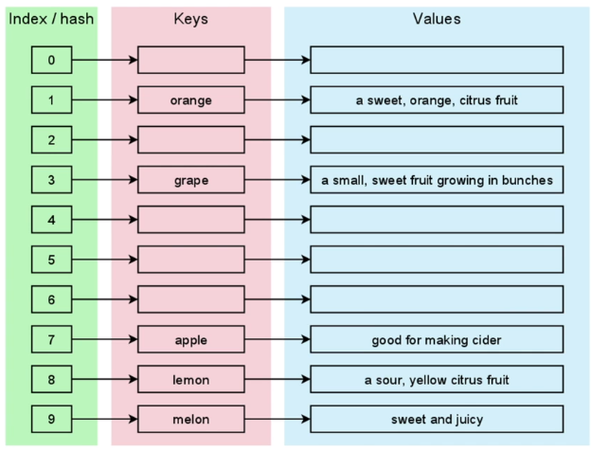

## hashlib

* <https://docs.python.org/3/library/hashlib.html>

## Introduction to sets

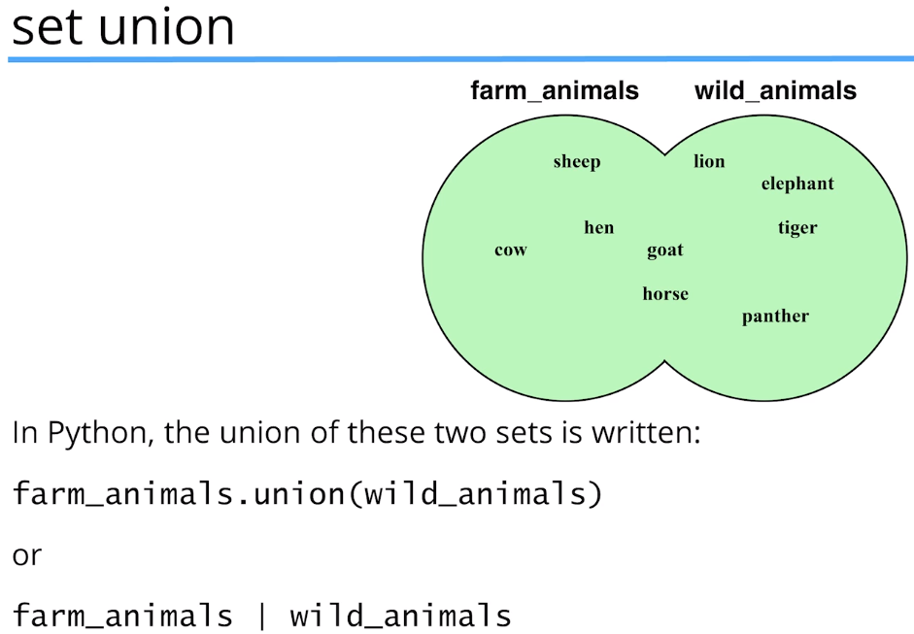

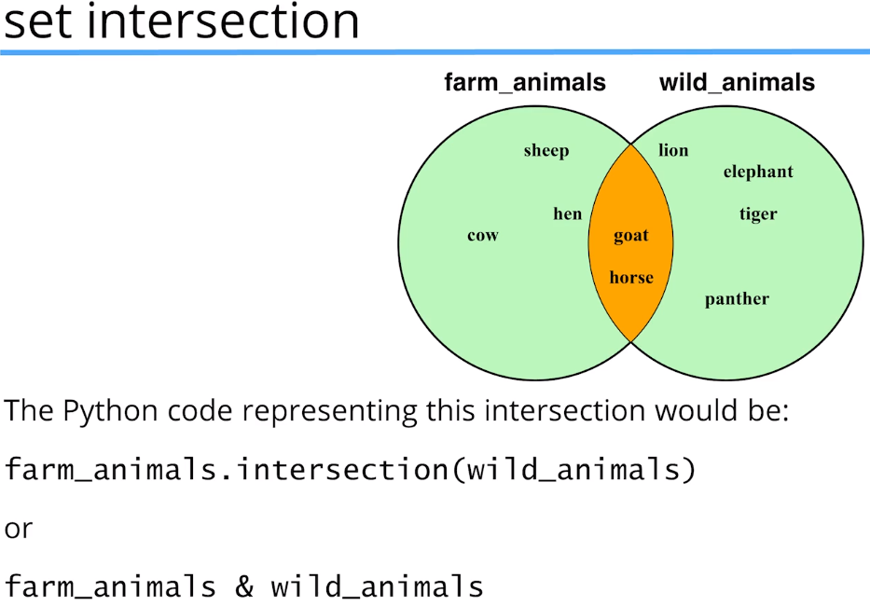

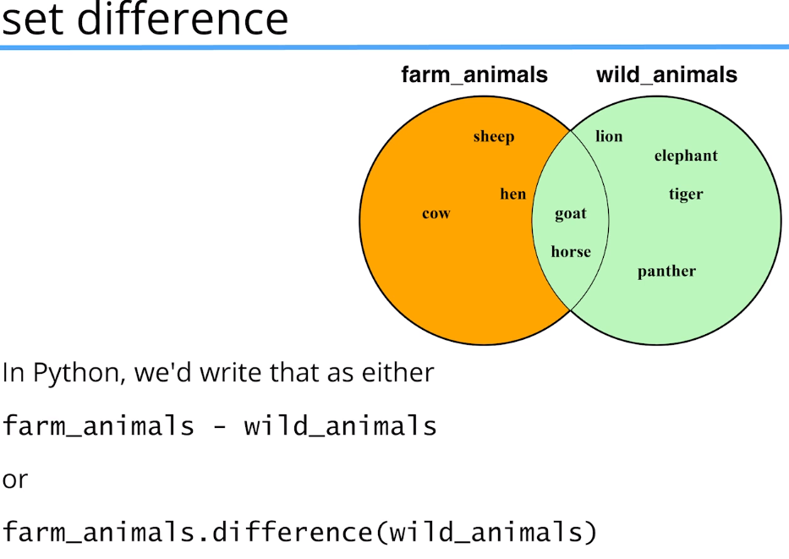

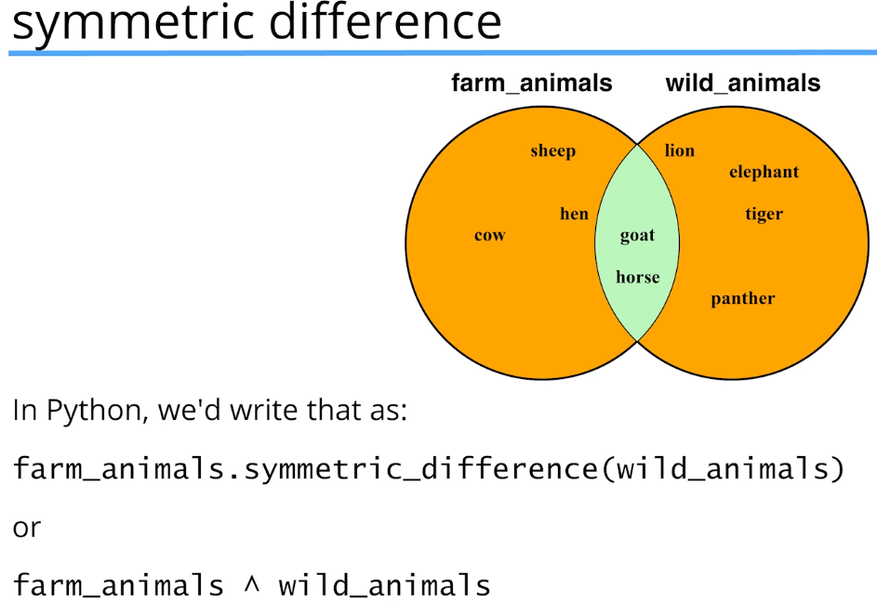

## set membership

choice = **"-"** *# initialise choice to something invalid***while** choice != **"0"**:  
 *# if choice in set("12345"):* **if** choice **in** {**"1"**,**"2"**,**"3"**,**"4"**,**"4"**}:  
 print(**"You chose {}"**.format(choice))  
 **else**:  
 print(**"Please choose your option from the list below:"**)  
 print(**"1:\tLearn Python"**)  
 print(**"2:\tLearn Java"**)  
 print(**"3:\tGo swimming"**)  
 print(**"4:\tHave dinner"**)  
 print(**"5:\tGo to bed"**)  
 print(**"0:\tExit"**)  
  
 choice = input()

## Better performance

*# if choice in set("12345"):***if** choice **in** {**"1"**,**"2"**,**"3"**,**"4"**,**"4"**}:

choice = **"-"** *# initialise choice to something invalid***while** choice != **"0"**:  
 *# if choice in "12345": Here's a BUG  
 # if choice in set("12345"):* **if** choice **in** {**"1"**,**"2"**,**"3"**,**"4"**,**"4"**}:  
 print(**"You chose {}"**.format(choice))  
 **else**:  
 print(**"Please choose your option from the list below:"**)  
 print(**"1:\tLearn Python"**)  
 print(**"2:\tLearn Java"**)  
 print(**"3:\tGo swimming"**)  
 print(**"4:\tHave dinner"**)  
 print(**"5:\tGo to bed"**)  
 print(**"0:\tExit"**)  
  
 choice = input()

Still better:

## Unique data in sets

data = [**"blue"**,**"red"**,**"blue"**,**"green"**,**"red"**,**"blue"**,**"white"**]  
  
*# Create a set from the list to remove duplicates*unique_data = set(data)  
print(unique_data)

## Set documentation

* <https://docs.python.org/3/library/stdtypes.html#set>

## The `pop` method

* <https://stackoverflow.com/questions/19378718/python-whats-the-use-case-for-set-pop>

## Set union

* <https://docs.python.org/3/library/stdtypes.html#set>

Clear() remove all elements from the set

Note, the non-operator versions of the [update()](https://docs.python.org/3/library/stdtypes.html#frozenset.update), [intersection_update()](https://docs.python.org/3/library/stdtypes.html#frozenset.intersection_update), [difference_update()](https://docs.python.org/3/library/stdtypes.html#frozenset.difference_update), and [symmetric_difference_update()](https://docs.python.org/3/library/stdtypes.html#frozenset.symmetric_difference_update) methods will accept any iterable as an argument.

**update**(*\*others*)

**set |= other | ...**

Update the set, adding elements from all others.

**from** prescription_data **import** adverse_interactions  
  
meds_to_watch = set()  
  
**for** interaction **in** adverse_interactions:  
 *# meds_to_watch = meds_to_watch.union(interaction)  
 # meds_to_watch = meds_to_watch | interaction  
 # meds_to_watch.update(interaction)* meds_to_watch |= interaction *# update*print(sorted(meds_to_watch))

## Symmetric Difference (you could use list)

*'''  
morning = {'Java', 'C', 'Ruby', 'Lisp', 'C#'}  
afternoon = {'Python', 'C#', 'Java', 'C', 'Ruby'}  
  
possible_courses = morning ^ afternoon  
print(possible_courses)  
'''*morning = [**'Java'**, **'C'**, **'Ruby'**, **'Lisp'**, **'C#'**]  
afternoon = [**'Python'**, **'C#'**, **'Java'**, **'C'**, **'Ruby'**]  
  
possible_courses = set(morning).symmetric_difference(afternoon)  
print(possible_courses)  
  
possible_courses = set(afternoon).symmetric_difference((morning))  
print(possible_courses)

## Subsets and supersets

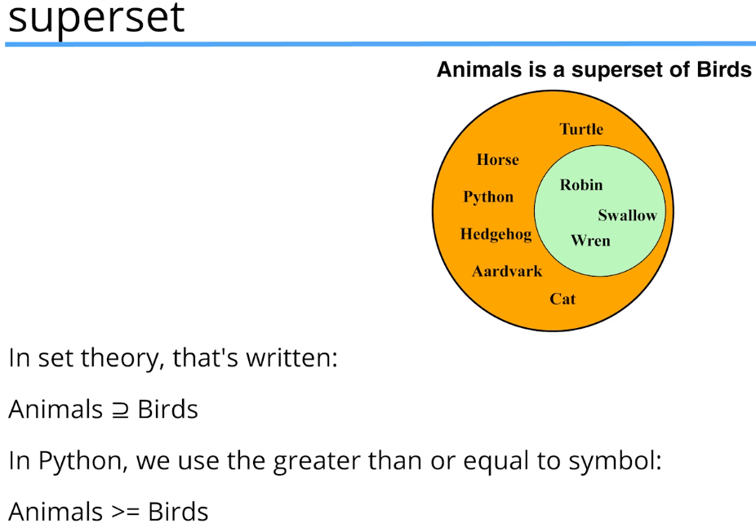

## isdisjoint(other)

**isdisjoint**(*other*)

Return True if the set has no elements in common with *other*. Sets are disjoint if and only if their intersection is the empty set.

## Summary

* <https://www.udemy.com/course/python-the-complete-python-developer-course/learn/lecture/27777626#questions>

# Section 8 Input and Output I/O

* <https://docs.python.org/3/library/functions.html#open>

jabber = open(**"sample.txt"**,**"r"**)  
*#jabber = open("C:\\Users\\lauri\\Downloads\\sample.txt","r")***for** line **in** jabber:  
 **if "jabberwock" in** line.lower():  
 print(line,end=**""**)  
  
jabber.close()

## Pickle

* <https://docs.python.org/3/library/pickle.html>
* pickle version 4 with Python 3.4 is *incompatible* downwards
* pickle.dump(imelda, pickle_file, protocol=0)

## Shelve

# Section 9 Modules and Functions

## Modules and import

**from** turtle **import** forward, right, done, circle  
  
done = **"Well done, you have finished your drawing!"**forward(150)  
right(250)  
circle(75)  
forward(150)  
  
done()  
print(done)

## The Standard Python Library

* <https://docs.python.org/3/library/functions.html#built-in-funcs>
* <https://docs.python.org/3.5/library/shelve.html>

## Webrowser Module

**import** webbrowser  
webbrowser.open(**"https://www.python.org"**)

<https://docs.python.org/3.4/library/webbrowser.html>

example: python -m webbrowser -t "http://www.python.org"

Example:

**import** webbrowser

url = **'http://docs.python.org/'***# Open URL in a new tab, if a browser window is already open.*webbrowser.open_new_tab(url)  
  
*# Open URL in new window, raising the window if possible.  
# webbrowser.open_new(url)*

## Time and Datetime in Python

* <https://docs.python.org/3/library/time.html>
* strftime
* <https://peps.python.org/pep-0418/>
* time.**strftime**(format[, t])
* <https://docs.python.org/3/library/datetime.html#module-datetime>
* *class*datetime.**tzinfo**

An abstract base class for time zone information objects. These are used by the [datetime](https://docs.python.org/3/library/datetime.html#datetime.datetime) and [time](https://docs.python.org/3/library/datetime.html#datetime.time) classes to provide a customizable notion of time adjustment (for example, to account for time zone and/or daylight saving time).

* <https://www.youtube.com/watch?v=-5wpm-gesOY> (The problem with Time & …)
* <https://mail.python.org/pipermail/python-dev/2002-March/020604.html>

## Installing pytz module (FAQ)

* <https://www.udemy.com/course/python-the-complete-python-developer-course/learn/lecture/13986636#questions>

## Installing pytz

c: > pip3 install pytz (as Admin)

C:\Users\lauri\AppData\Local\Programs\Python\Python310\python.exe -m pip install --upgrade pip

## Using Timezones

* <http://www.iana.org/time-zones>
* <http://pytz.sourceforge.net/>

## Tkinter

* <https://docs.python.org/3/library/tk.html>
* <https://tkdocs.com/>
* <https://anzeljg.github.io/rin2/book2/2405/docs/tkinter/index.html>
* <https://en.wikipedia.org/wiki/Tk_%28software%29>

## Import System

* <https://docs.python.org/3/reference/import.html>

blackjack.py &

import_test.py

**import** blackjack  
  
*# from command line: python -m blackjack*print(__name__)  
blackjack.play()  
print(blackjack.cards)

## Lesson 288 recursive or iterative

### Factorial and Fibonacci

**def** fact(n):  
 *""" calculate n! iteratively"""* result = 1  
 **if** n > 1:  
 **for** f **in** range(2, n + 1):  
 result *= f  
 **return** result  
  
**def** factorial(n):  
 *# n! can also be defined as n * (n-1)!* **if** n <= 1:  
 **return** 1  
 **else**:  
 **return** n * factorial(n-1)  
  
**def** fib(n):  
 *""" F(n) = F(n - 1) ? F(n - 2) """* **if** n < 2:  
 **return** n  
 **else**:  
 **return** fib(n-1) + fib(n-2)  
  
**def** fibonacci(n):  
 **if** n == 0:  
 result = 0  
 **elif** n == 1:  
 result = 1  
 **else**:  
 n_minus_1 = 1  
 n_minus_2 = 0  
 **for** f **in** range(1, n):  
 result = n_minus_2 + n_minus_1  
 n_minus_2 = n_minus_1  
 n_minus_1 = result  
 **return** result  
  
**for** i **in** range(36):  
 print(i, fib(i), **"\t"**, fibonacci(i))

## OS module

* <https://docs.python.org/3/library/os.html>

## Nonlocal keyword, FREE and LEGB

* <https://docs.python.org/3/library/functions.html#locals>

# Section 10 – Object Oriented Programming

*Class: template for creating objects. All objects created using the same class will have the same characteristics.*

*Object: an instance of a class.*

*Instantiate: create an instance of a class.*

*Method: a function defined in a class.*

*Attribute: a variable bound to an instance of a class.*

### Capsulation in Classes check from material

Example:

**class** Account:  
 *""" Simple account class with balance """* **def** __init__(self, name, balance):  
 self.name = name  
 self.balance = balance  
 print(**"Account created for "** + self.name)  
  
 **def** deposit(self, amount):  
 **if** amount > 0:  
 self.balance += amount  
 self.show_balance()  
  
 **def** withdraw(self, amount):  
 **if** amount > 0 **and** amount < self.balance:  
 self.balance -= amount  
 **else**:  
 print(**"Failed to withdraw - balance on your account must be more than the withdraw amount"**)  
 self.show_balance()  
  
 **def** show_balance(self):  
 print(**f"Balance is {self.balance} €"**)  
  
**if** __name__ == **'__main__'**:  
 lasse = Account(**"Lasse"**,0)  
 lasse.show_balance()  
  
 lasse.deposit(1000)  
 lasse.withdraw(200)  
 lasse.deposit(100)

### Static Methods:

As far as i understand it's used without using "self" and it's being shared on all the class methods?

That's about all there is to it.  The attribute belongs to the class, and you can call it without creating a class instance - in fact, you shouldn't use an instance to call it.

Generally, you'd use a static method for something that doesn't use any of the instance attributes but that may be useful to users of the class.

### Namespaces:

In Python, everything is an object, and names (variable names), also referred to as identifiers, are labels associated with those objects. One of the main ways of accessing an object is via its name.

A namespace is an isolated collection of names mapped to their corresponding objects. Different objects can have the same name and not collide as long as those names are in different namespaces.

Every module creates its own namespace. Each class has its own namespace, and a function creates its own namespace each time it is run.

Namespaces are related to scopes. Each scope has a corresponding namespace, and can be defined as the section of the program where you can access that namespace without any prefixes.

## DocString and Raw Literals

<https://peps.python.org/pep-0257/>

## Artist Class and import Albums (with circular reference)

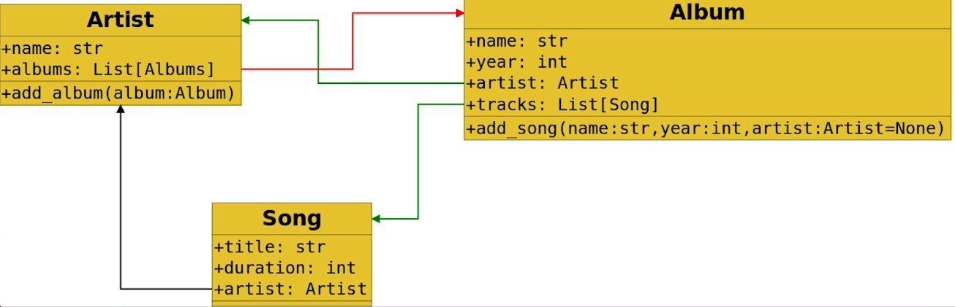

## Compare Files and Algorithm Flowcharts

1. select files to be compared + CTRL + D or View + Compare Files:
   * opens a new window
2. select one file + CTRL + D opens files directory to select the other file to be combared

### If using Python 2 in song.py

this line wouldn’t work:

print(**"{0.name}\t{1.name}\t{1.year}\t{2.title}"**.format(new_artist, new_album, new_song),file=checkfile)

But using import as following it should work

import from __future__ import print_function

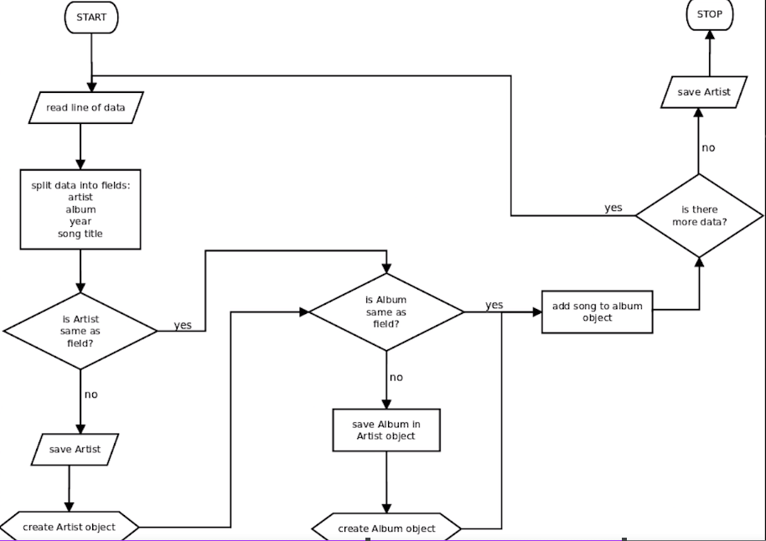

New one

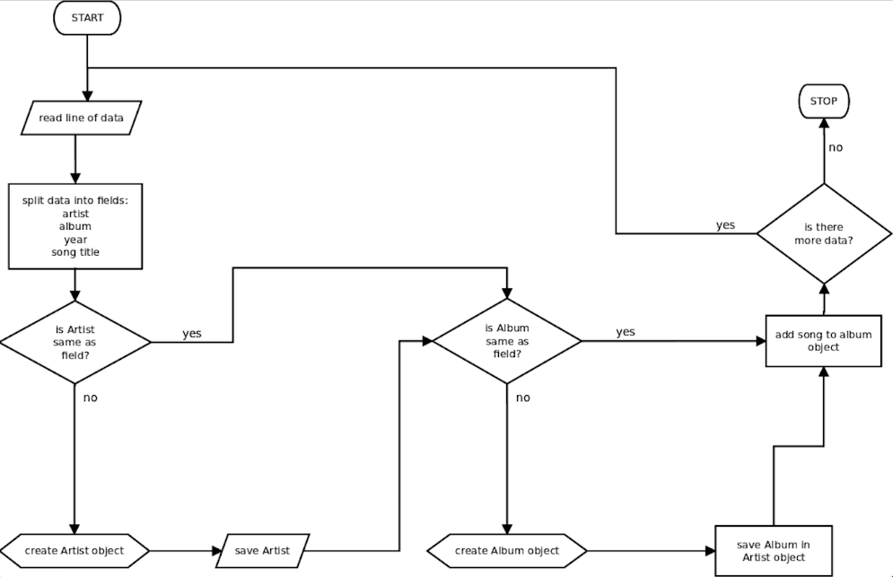

Latest one

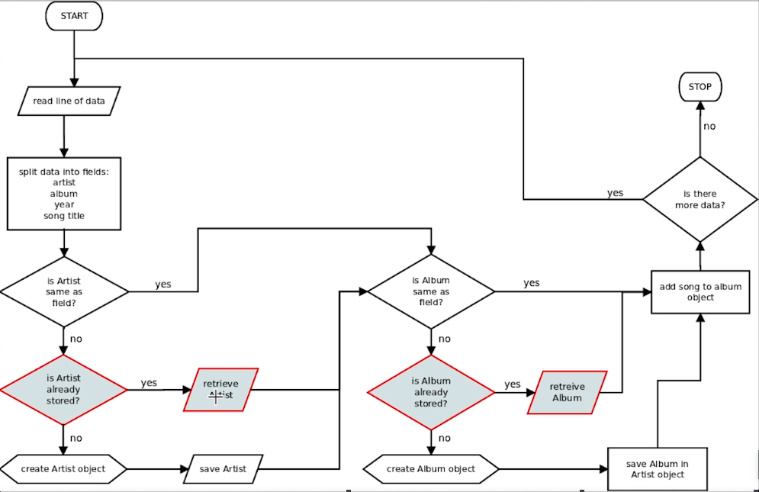

## Challenge – remove circular references (aim to top diagram)

## Getters and Setters

* <https://docs.python.org/3.5/library/functions.html#property>

## Inheritance (Python allows multiple inheritance but be aware that you should master it)

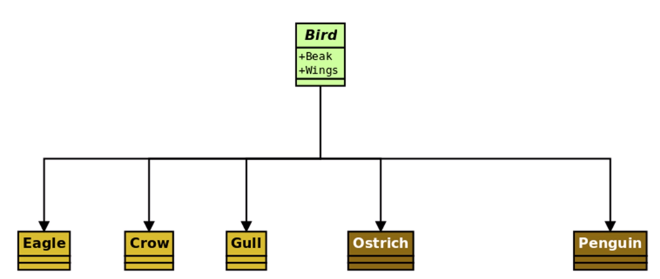

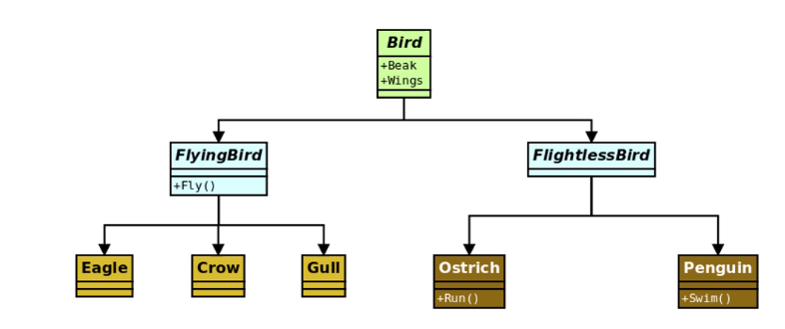

### Python no method overloading

### Python overriding

### tab Regex + (\{\d\.) + $1_ Replace All

### Inheritance Challenge Lesson 314

**import** random  
  
*# class Enemy:***class** Enemy(object): *# with Python 2, with Python 3 either is Ok* **def** __init__(self, name=**"Enemy"**, hit_points=0, lives=1):  
 self._name = name  
 self._hit_points = hit_points  
 self._lives = lives  
 self._alive = **True  
  
 def** take_damage(self, damage):  
 remaining_points = self._hit_points - damage  
 **if** remaining_points >= 0:  
 self._hit_points = remaining_points  
 print(**"I took {} points damage and have {} left"**.format(damage, self._hit_points))  
 **else**:  
 self._lives -= 1  
 **if** self._lives > 0:  
 print(**"{0._name} lost a life"**.format(self))  
 **else**:  
 print(**"{0._name} is dead"**.format(self))  
 self._alive = **False  
  
 def** __str__(self):  
 **return "Name: {0._name}, Lives: {0._lives}, Hit points: {0._hit_points}"**.format(self)  
  
  
**class** Troll(Enemy):  
  
 **def** __init__(self, name):  
 *# Enemy.__init__(self, name=name, hit_points=23)  
 # super(Troll, self).__init__(name=name, lives=1, hit_points=23)* super().__init__(name=name, lives=1, hit_points=23)  
  
 **def** grunt(self):  
 print(**"Me {0._name}. {0._name} stopm you"**.format(self))  
  
**class** Vampyre(Enemy):  
  
 **def** __init__(self, name):  
 super().__init__(name=name, lives=3, hit_points=12)  
  
 **def** dodges(self):  
 **if** random.randint(1,3) == 3:  
 print(**"******** {0._name} dodges ********"**.format(self))  
 **return True  
 else**:  
 **return False  
  
 def** take_damage(self, damage):  
 **if not** self.dodges():  
 super().take_damage(damage=damage)  
  
**class** VampyreKing(Vampyre):  
  
 **def** __init__(self,name):  
 super().__init__(name=name)  
 self._hit_points = 140  
  
 **def** take_damage(self, damage):  
 **if not** self.dodges():  
 super().take_damage(damage//4)

## Polymorphism (Java in statically typed – Python dynamically typed)

### Inheritance isn’t the only way to implement polymorphism Lesson316

* <https://en.wikipedia.org/wiki/Duck_test>

## Composition Lesson 317 & 319 HTML document demo

* <https://www.w3.org/TR/html401/struct/global.html>

### Relationship described with

IS a -> inheritance

Has a -> composition

## Aggregation (weak form of composition) Lesson 320

# Section 11 – Using Databases with Python

## Introduction to SQLite

* <https://sqlite.org/index.html>

1. added to path C:\Users\sqlite-tools-win32-x86-3380100
2. c:> sqlite3
3. sqlite> .quit

sqlite3 test.db

.help

.headers on

create table contacts (name text, phone integer, email text);

insert into contacts (name, phone, email) values('Lasse', 05009898989, 'lasse@gmail.com');

insert into contacts(name, phone) values("Steve", 04599888); # also succeeds in sqlite3

if session closed reopen:

*.open test.db* OR just in start: *sqlite3 music.db*

SELECT * FROM contacts; or use graphical DB browser for sqlite

.backup testbackup

.restore ***How to use?***

update contacts set email="brian@gmail.com" where name ="Brian";

delete from contacts where name="Brian";

.tables

.schema

.dump

## Querying data with SQLite

copied music.db to -> c:/users/lauri

.schema

.headers on

select * from albums where _id="367";

### Autoincrement in SQLite

* <https://www.sqlite.org/autoinc.html>

select * from artists order by name;

select * from artists order by name collate nocase;

select * from artists order by name desc; # OR asc

select * from albums order by artist, name collate nocase;

select * from songs order by album, track;

select * from albums where _id=439;

select * from artists where _id=133;

Join:

* select songs.track, songs.title, albums.name FROM songs JOIN albums ON songs.album = albums._id;
* select track, title, name FROM songs JOIN albums ON songs.album = albums._id;

## More Complex Joins

INNER JOIN

* select songs.track, songs.title, albums.name FROM songs INNER JOIN albums ON songs.album = albums._id;
* select songs.track, songs.title, albums.name FROM songs INNER JOIN albums ON songs.album = albums._id ORDER BY albums.name, songs.track;

select albums.name, songs.track, songs.title FROM songs INNER JOIN albums ON songs.album = albums._id ORDER BY albums.name, songs.track;

select albums.name, artists.name from albums inner join artists on albums.artist=artists._id order by artists.name;

select artists.name, albums.name from albums inner join artists on albums.artist=artists._id order by artists.name;

select artists.name, albums.name from albums inner join artists on albums.artist=artists._id where artists.name = “Alice Cooper”;

select artists.name, albums.name, songs.track, songs.title FROM songs

INNER JOIN albums ON songs.album = albums._id

INNER JOIN artists ON albums.artist = artists._id

ORDER BY artists.name, albums.name, songs.track;

select artists.name, albums.name from albums inner join artists on albums.artist=artists._id where albums.name = “Doolitle”;

## Wildcards and Views

select artists.name, albums.name, songs.track, songs.title FROM songs

INNER JOIN albums ON songs.album = albums._id

INNER JOIN artists ON albums.artist = artists._id

WHERE songs.title LIKE "%doctor%"

ORDER BY artists.name, albums.name, songs.track;

select artists.name, albums.name, songs.track, songs.title FROM songs

INNER JOIN albums ON songs.album = albums._id

INNER JOIN artists ON albums.artist = artists._id

WHERE artists.name LIKE "jefferson%"

ORDER BY artists.name, albums.name, songs.track;

### Views (for customer security plus to easy job)

CREATE VIEW artist_list AS

SELECT artists.name, albums.name, songs.track, songs.title FROM songs

INNER JOIN albums ON songs.album = albums._id

INNER JOIN artists ON albums.artist = artists._id

ORDER BY artists.name, albums.name, songs.track;

select * from artist_list where name LIKE "jefferson%";

CREATE VIEW album_list AS

SELECT name FROM albums

ORDER by NAME;

DROP VIEW album_list;

CREATE VIEW album_list AS

SELECT name FROM albums

ORDER by NAME COLLATE NOCASE;

select * from artist_list where name like "jefferson%";

.headers on

GIVES two name-fields on output:

sqlite> select * from artist_list where name like "jefferson%";

name|name:1|track|title

Jefferson Airplane|Surrealistic Pillow|1|She Has Funny Cars

Jefferson Airplane|Surrealistic Pillow|2|Somebody To Love

DROP VIEW album_list;

CREATE VIEW album_list AS

SELECT artists.name AS artist, albums.name AS album, songs.track, songs.title from songs

INNER JOIN albums ON songs.album = albums._id

ORDER by artists.name, albums.name, songs.track;

select * from artist_list where name like "jefferson%";

HEADERS WERE STILL THE SAME

## Housekeeping and Challenge

delete from songs where track < 50;

select * from songs where track <> 71;

select count(*) from songs;

## SQL Challenge

1. select songs.track, songs.title, albums.name FROM songs INNER JOIN albums ON songs.album = albums._id where albums.name = "Forbidden";
2. select songs.track, songs.title, albums.name FROM songs INNER JOIN albums ON songs.album = albums._id where albums.name = "Forbidden" ORDER BY albums.name, songs.track;

select artists.name, songs.track, songs.title FROM songs

INNER JOIN albums ON songs.album = albums._id

INNER JOIN artists ON albums.artist = artists._id

WHERE artists.name = "Deep Purple"

ORDER BY artists.name, albums.name, songs.track;

OR

select * from artist_list where name = “Deep Purple”;

1. update artists set name = "One Kitten" where name = "Mehitabel";
2. Ok – select * from artists where artists.name = "One Kitten";

6.

select songs.title FROM songs

INNER JOIN albums ON songs.album = albums._id

INNER JOIN artists ON albums.artist = artists._id

WHERE artists.name = "Aerosmith"

ORDER BY songs.title COLLATE NOCASE;

OR

select title from artist_list where name = “Aerosmith” order by title;

7.

select count(title) FROM songs

INNER JOIN albums ON songs.album = albums._id

INNER JOIN artists ON albums.artist = artists._id

WHERE artists.name = "Aerosmith"

ORDER BY songs.title;

8.

select distinct songs.title FROM songs

INNER JOIN albums ON songs.album = albums._id

INNER JOIN artists ON albums.artist = artists._id

WHERE artists.name = "Aerosmith"

ORDER BY songs.title COLLATE NOCASE;

9.

SELECT COUNT(DISTINCT songs.title) FROM songs

INNER JOIN albums ON songs.album = albums._id

INNER JOIN artists ON albums.artist = artists._id

WHERE artists.name = "Aerosmith"

ORDER BY songs.title COLLATE NOCASE;

10.

SELECT COUNT(DISTINCT artists.name) FROM songs

INNER JOIN albums ON songs.album = albums._id

INNER JOIN artists ON albums.artist = artists._id

WHERE artists.name = "Aerosmith"

ORDER BY songs.title COLLATE NOCASE;

## SQL in Python

## SQL Injection Attacks (parameter substitution with placeholders, sanitizing the input)

update_sql = **"UPDATE contacts SET email = ? WHERE phone = ?"**print(update_sql)

## Placeholders and Parameter Substitution

**import** sqlite3  
  
db = sqlite3.connect(**"contacts.sqlite"**)  
  
name = input(**"Please enter the name: "**)  
  
**for** row **in** db.execute(**"SELECT * FROM contacts WHERE name LIKE ?"**, (name,)):  
 print(row)  
  
db.close()

## Exceptions

* <https://docs.python.org/3/library/exceptions.html>

### Hints (CTRL + Q)

* <https://peps.python.org/pep-0484/>

## Adding Database code to Accounts Class

* <https://sqlite.org/datatype3.html>

C:\Users\lauri\PycharmProjects\PythonMasterClass\RollingBack\

## Displaying Time in Different Timezones

* <https://docs.python.org/3.5/library/sqlite3.html>
* sqlite3.**PARSE_DECLTYPES**

## SQLite3 strftime Function

* <https://sqlite.org/lang_datefunc.html>

## Challenge and Problems Storing Time zones

## - <https://www.sqlite.org/lang_corefunc.html>

## - <https://www.sqlite.org/lang_aggfunc.html>

## Jukebox (Music Browser)

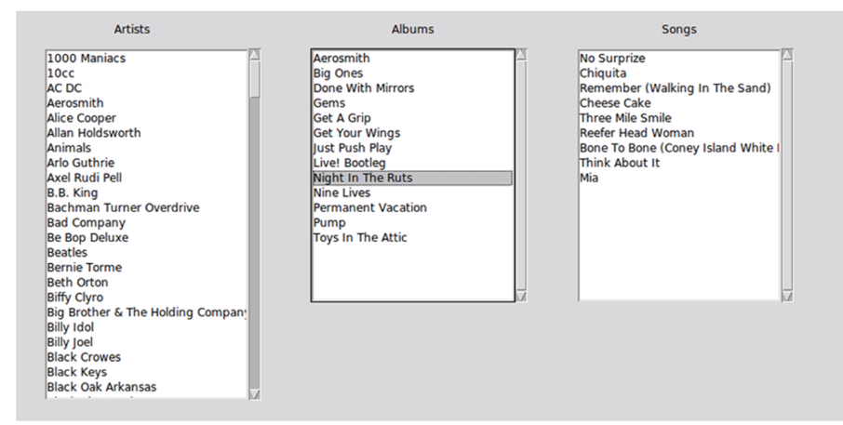

## Star args

in case of Python 2:

**from** __future__ **import** print_function

---------------------------------------------------------------------------

**def** average(*args):  
 print(type(args))  
 print(**"args is {}"**.format(args))  
 print(**"*args is:"**, *args)  
 mean = 0  
 **for** arg **in** args:  
 mean += arg  
 **return** mean / len(args)  
  
print(average(1,2,3,4))

**def** build_tuple(*args):  
 **return** (args)  
  
message_tuple = build_tuple(**"hello"**, **"planet"**, **"earth"**,**"take"**,**"me"**,**"to"**,**"your"**,**"leader"**)  
print(type(message_tuple))  
print(message_tuple)  
  
number_tuple = build_tuple(1,2,3,4,5,6)  
print(type(number_tuple))  
print(number_tuple)

example:

* reverse a string [::-1]
* <https://docs.python.org/3/tutorial/controlflow.html#more-on-defining-functions>

**def** return_string(*args):  
 **return** (args[::-1])  
  
message = return_string(**"hello"**, **"planet"**, **"earth"**, **"take"**, **"me"**, **"to"**, **"your"**, **"leader"**)  
print(message)

**def** print_backwards(*args, file=**None**):  
 **for** word **in** args[::-1]:  
 print(word[::-1], end=**' '**, file=file)  
  
**with** open(**"backwards.txt"**,**"w"**) **as** backwards:  
 print_backwards(**"hello"**,**"how"**,**"do"**,**"you"**,**"do"**, file=backwards)

# Jukebox final

C:\Users\lauri\PycharmProjects\PythonMasterClass\MusicBrowser

select albums.name, count(albums.name) num_albums from albums group by albums.name having num_albums >1;

select artists._id, artists.name, albums.name from artists

inner join albums on albums.artist = artists._id

where albums.name in

(select albums.name from albums group by albums.name having count(albums.name) > 1)

order by albums.name, artists.name;

SELECT name, _id FROM albums WHERE name ='Greatest Hits';

SELECT name, _id, artist FROM albums WHERE name ='Greatest Hits' AND artist = 176;

select * from songs where album = 399;

Questions:

* <https://www.udemy.com/course/python-the-complete-python-developer-course/learn/lecture/23347020#questions/16829468>